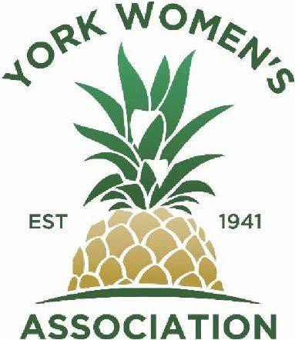
Membership Application
Club Year 2020-2021

PLEASE PRINT

Date ____________________ Name:

Address:

Home Phone: Cell Phone:

Email: _____________________________________________________________ Birth Date (Mo/Day/Year)
How did you hear about the York Women’s Association? (Please circle)

Member Friend Newspaper Flyer Website Facebook Other_____________________________________
Referred By:

The best time to contact me is

Signature: _______________________________
Yearly Membership Dues: $35 Make check payable to “York Women’s Association” Return this Membership Application & $35 dues to:

York Women’s Association, 5 South Broad Street #493, New Freedom, PA 17349

New members may contact bejacoby@outlook.com with questions.

We will be in touch with you soon. Thank you, and WELCOME!

